Using surveys as part of fieldwork

Questionnaires and surveys are an excellent way to examine a subject in the field. They can be used to sample public opinion on an issue. For example a survey could investigate the views of local residents on the impacts of a new road or it could identify the most important reasons why industry locates where it does.

A questionnaire provides a standardized format that allows you to ask the same questions.

The design of a good questionnaire should allow participants to quickly answer questions. An effective way to do this is to provide a limited range of responses for participants to choose from.

The following sample is taken from a geography project investigating consumer patterns in the UK.

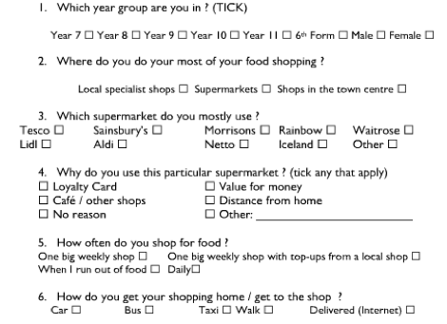

A similar survey can be used to identify important influencing factors. In the following example the survey is based on different types of industry and the factors influencing their location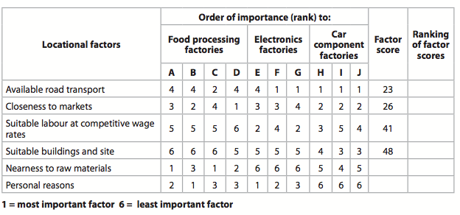
39
33

With this survey the participants are factories and they are given a very clear set of possible responses. The difference here is that a scoring method is used to rank the importance, with the lowest score being the most important.

A third type of survey can be used to investigate people’s perception of an area. An Environmental Quality Index allows you to score a site on a number of different environmental criteria. The example below is for shopping but alternatively you could focus on street quality and include more specific environmental factors

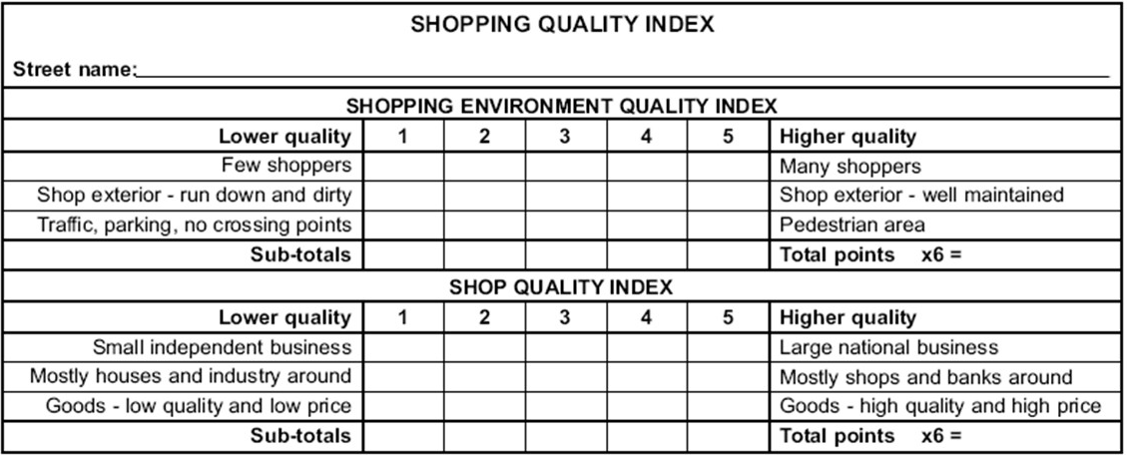

For a snapshot of perception, bipolar surveys can be used. The following shows a bipolar survey on an urban area. It using opposing adjectives and participants tick close to more appropriate adjective that best describe their own perception or experience.

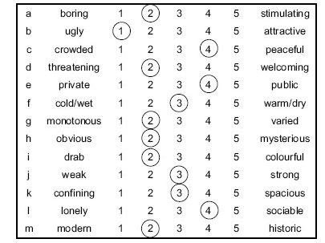

When designing a survey it’s very important to consider the following:

- The aims of your survey
- The interest group
- The sample size
- The sample method
- The location and timing of the survey

- Your questions should be very clearly linked to your aims.

- You should consider carefully the important interest groups and ensure you sample each group equally.

- The sample size should be sufficient and balanced in terms of different groups. If the sample is too small then our findings would be limited and unreliable.

- The sample method relates to how you choose the participants, this might be random or it may be targeted at different age groups or gender or organizations.

- It’s important to consider where you will do a questionnaire. You need to target a time and place where you will find people willing to give up their time.

Finally your survey should be designed in a way that allows you to quickly record, collate and analyse your results.

